MGMT 2150 Exam Prep

# What we are covering

Chapters 3,6,7,8,9,12 and 16

DOES NOT cover sections 3.4, 3.5, and 3.6 (Chapter 3: Sections 4, 5, and 6) - Section 16.4 (Chapter 16: Section 4) is included in the exam, but only up until “Types of Warranty” - DOES NOT cover section 16.5 (Chapter 16: Section 5)

# Chapter 3: Business in a Global Environment

## Why Trade?

* No nation can produce all goods and services

## Terms

Trade Surplus: Sells more than it buys

Trade Deficit: Buys more than it sells

National Expenses: Military, International Loans, Foriegn Investments

## Balance Payments

Balance Payments Decrease when we “import” more than we “export”, and Balance Payments Increase when we “Export” more than we “Import”

Example:

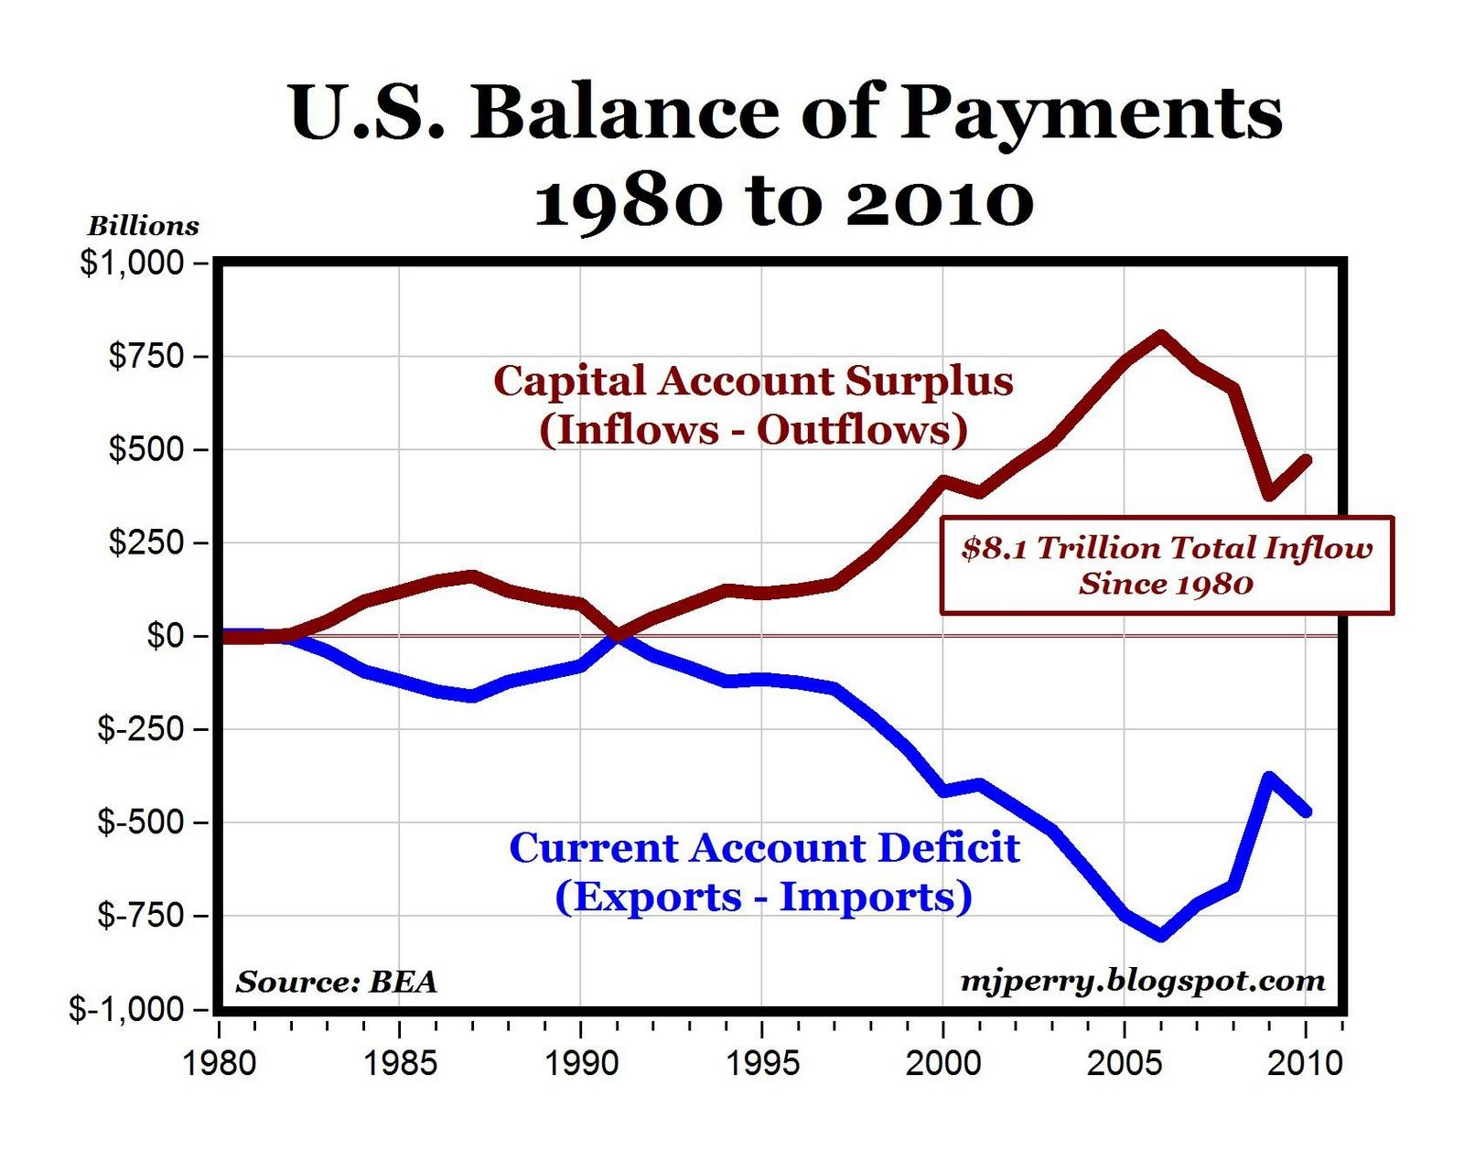

## Multinational Corporations

### Criticism

* Destories jobs and lowers wages of home country workers
* Traditional Lifestyle / Values weakened or destroyed.
* Irreversible damage to the environment.

### Defense

* Better, Cheaper, Products
* Creates Jobs
* Raises Standard of living in developing countries
* Increase cross cultural understanding

## Cultural Environment

### High-Context Culture

* Non-verbal plays a big role
* Personal Relationship
* Cultural Cues

### Low-Context Culture

* Written or spoken at face value
* Relationships are not necessary

## Negotiations (Low-Context Culture)

* Arguing
* Exaggerated counter proposals
* Ceasing communication
* Disagreements
* Threatening
* Expressing emotions
* A final Position
* Take it or leave it